Foreman’s Report 2: Heat Exchange

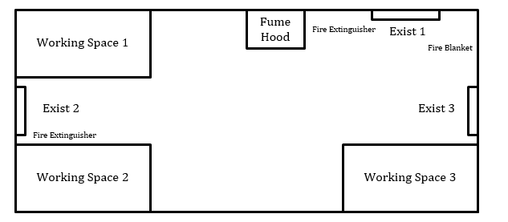

Safety

Physical Hazards

1. Burns: The heat exchange apparatus has two heated streams. One is a steam stream (~100 °C), and the other is a hot water stream (~80 °C). Both streams can cause burns on the hands and arms through the piping because the piping is not insulated. Use insulated gloves to protect hands – use caution when handling 80 °C.
2. Pinching of hands or fingers: The tubing that connects the 3 way diverter valve for the water stream to the rest of the piping, and the heat exchangers is connected through a push fit connector. These valves can tend to stick and it can sometimes be difficult to get the tubing end all the way into the valve. Being cautious of hand placement can be important to prevent pinching fingers, or other parts of the hand.
3. Emergency Circumstances: Under emergency circumstances turn off the steam flow, and exit the lab in a safe and quick manner through one of the three exits.

Experimental Apparatus

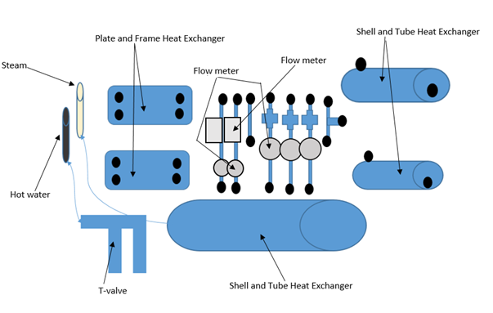

T-pipe

Figure 1: Heat exchanger, and connected pipes

All of the equipment used in the heat exchange process is shown in Figure 1. The steam enters the large shell and tube heat exchanger at the bottom of the figure though the shell side (the steam goes in the shell side because when it condenses there are fewer problems with pressure drops and change in flow, and the water enters a 3 way diverter. The one of the pipes from the three way diverter goes into the shell side of the large shell and tube heat exchanger, and the other two are broken into two streams that are controlled by nobs located on the left side of each of the exiting pipes. The flow for these two streams is controlled manually for the system. These pipes have push fit connectors that allow rubber tubing to be connected from the source to any of the heat exchangers, and any of the pipes in between.

There are two Shell and Tube heat exchangers, and two Plate and Frame heat exchangers in the system. The Shell and Tube heat exchangers have a baffled shell side to optimize counter current flow, and improve the heat transfer. An example of a Shell and Tube heat Exchanger can be seen in Figure 3. The Plate and Frame heat exchangers also use counter current flow and heat exchange through alternating plates. An example of a Plate and Frame heat exchanger can be seen in Figure 2. Each heat exchanger has a thermocouple on each inlet and outlet that are connected to the VI.

There are 5 round flow meters that are connected to the central VI on the computer, the data is recorded there. They can be seen in Figure 1. There are also two square flowmeters that can also be set to control the flow from the VI. Those can be seen as the two square flow meters in Figure 1. The setup also includes three manual valves that can adjusted to change the flow.

The central VI gives data for the temperature of each stream, the flow rate, and allows for the flow rate for the two automated square flow meters to be adjusted based upon a change in voltage.

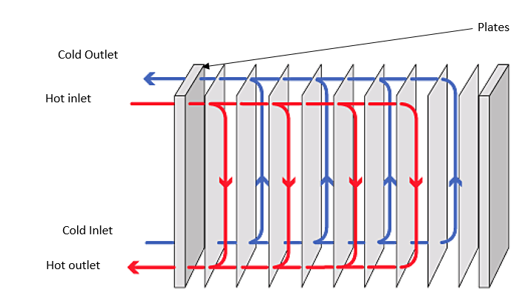

Figure 2: Plate and Frame heat exchanger

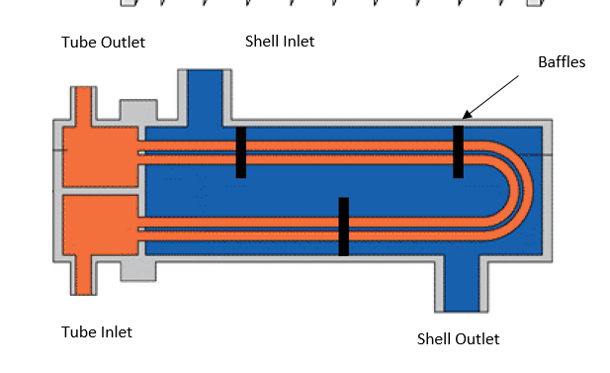

Figure 3: Shell and Tube heat exchanger

Total heat transfer for a system would occur if the two outlet streams for a heat exchanger came out at the opposite streams inlet temperature. For example if stream 1 went in at 80°C and stream 2 went in at 30°C stream 1 would come out at 30°C and stream 2 would come out at 80°C. For this trial however, we are designing for a pinch point at which the outlets of both streams of water would reach the same temperature. Since this in not actually possible, we would consider anything ±10 °C to have exchanged heat.

Experimental Procedure

1. Attach the hot water hose (black) that is coming out of the large heat exchanger to the top inlet of the T- pipe on the right side of the equipment. (CP)
   1. This will not need to be moved during the trial
2. Attach two (two sided) hoses to the other two outlet of the T-pipe and attach each of these two hoses to the two pipes with the automated valves, and the flow meters.
   1. These will not need to be moved from the T-pipe during the trial (CP)

Creating networks to find Over All Heat Transfer (U):

During the trial it is important to calculate the U values for the three possible heat exchangers. This data can then be used to both determine the efficiency of each of the heat exchangers, as well as to determine if these heat exchangers would be compatible for other heat transfer specifications for other trials. U can be calculated using the following equations.

Where

and F (the correction factor) is calculated from Z and Y and found using the following chart and equations. F must be greater than 0.8 because at a value lower than 0.8, the U value will be too greatly affected by small changes in temperature to get accurate results.

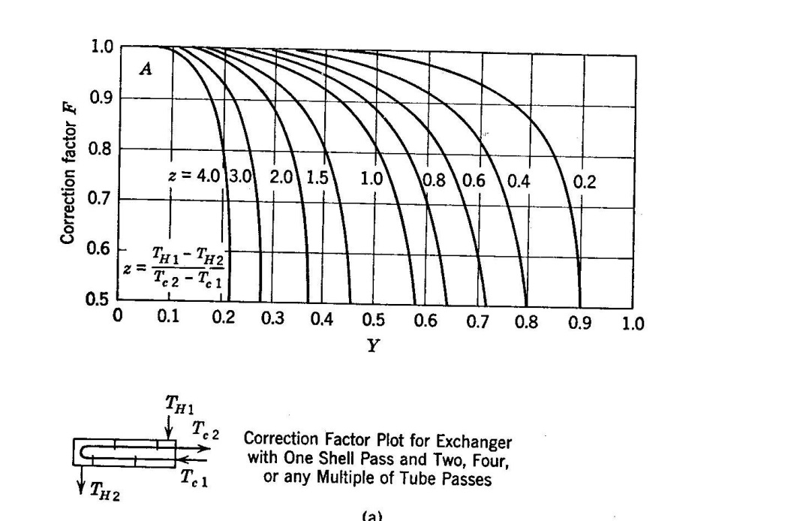





Where ΔTlm is

1. Attach one of the pipes with the automated valves to one of the P&F exchanger inlet
   1. The outlet of this pipe will be connected to the second S&T exchanger in that series
2. Attach one of the yellow tubes to one of the pipes with the manually adjustable valves on them. Connect the outlet to the other inlet of the P&F exchanger. Connect the outlet to an open ended tube. (JG)
   1. Loop the open end of the tube over the upper bar of the structure, and put it down the drain
3. Attach the remaining tube from the pipes with the automated valves to the tube side of one of the S&T exchangers and then connect that outlet to the tube inlet for the second S&T exchanger (JG)
   1. Note which exchanger is used first (GG)
4. Attach remaining yellow tube to one of the pipes with the manually adjustable valves on them. Connect the outlet to the shell side of the S&T exchanger. (CP)
   1. Attach an open ended tube to the shell side outlet of the first S&T exchanger and loop it over the top of the structure, and put it down the drain
5. Attach the cooling water outlet of the P&F exchanger to the shell side inlet of the second S&T exchanger (JG)
6. Attach open ended tubes to both outlets of the second S&T exchanger (CP)
   1. Loop the open ends of the tubes over the upper bar of the structure, and put them down the drain.
7. Hook up the appropriate (used) thermocouples to the inlets on the circuit board (GG)
   1. Record what ports are for what thermocouples and which streams they are attached to on each exchanger (GG)
8. Turn on the cold water, and adjust the valves to they read the amounts listed in the flow chart in Experimental Runs section for each stream (JG)
9. Turn on the steam and allow the system to heat up (CP)
10. Collect temperature and flow rate data (GG)
11. Calculate Q and U values for each exchanger after run one (GG)
    1. Calculate Q and U values after each successive run (GG)

For each of the three trials make sure the water and the steam are both turned off (TURN OFF STEAM FIRST) before un-hooking any of the piping. Tubing connections for all of the runs are listed in Table 1

Experimental runs

RUN 1:

-Black tube with hot water (80C) → top inlet on T-pipe on right side of apparatus→ bottom of T-pipe connects to far left pipe with automated valve → bottom of pipe connects to top left inlet of P&F exchanger → outlet of P&F exchanger connects to open ended pipe → drain (flow rate should be 2 l/min and temperature on outlet should be 55C)

- Black tube with hot water (80C) → top inlet on T-pipe on right side of apparatus → left outlet of T-pipe connects to second pipe with automated valve → bottom of pipe connects to tube inlet of top S&T exchanger → tube outlet of S&T exchanger connects to tube inlet of bottom S&T exchanger → tube outlet of bottom S&T exchanger connects to an open ended pipe → drain (flow rate should be 3.3 l/min and temperature on outlet should be 40C)

-Yellow tube #1 with cold water (25C) → connects to far left pipe with manual valve → bottom of pipe connects to inlet of the P&F (for counter current flow) → (flow rate at this point should be 4 l/min and temperature should be 37C) outlet of P&F exchanger connects to inlet of bottom S&T exchanger → outlet of S&T exchanger connects to open ended pipe → drain (flow rate should be at 4 l/min and temperature should be 53C)

-Yellow tube #2 with cold water (25C) → connects to far left pipe with manual valve → bottom of pipe connects to inlet of the top S&T exchanger → outlet of S&T exchanger connects to open ended pipe → drain (flow rate should be at 3 l/min and temperature at outlet should be 46C)

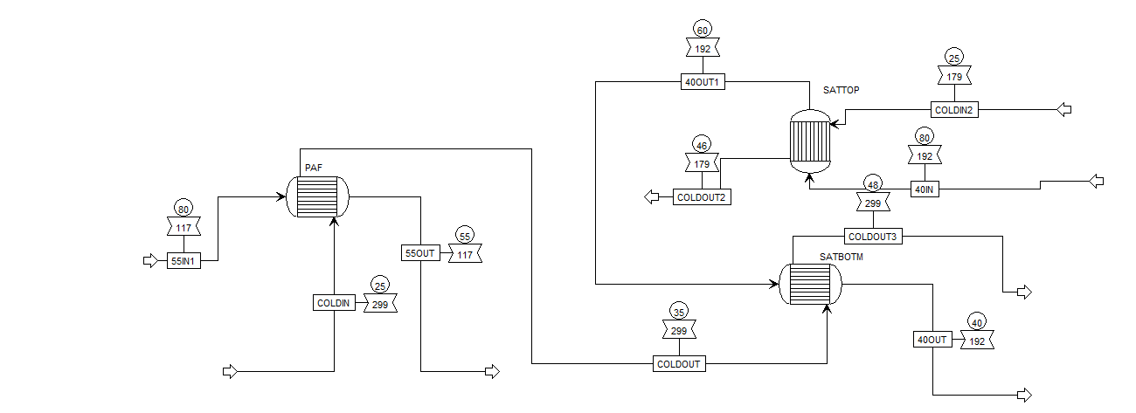

RUN 2:

-Black tube with hot water (80C) → top inlet on T-pipe on right side of apparatus→ bottom of T-pipe connects to far left pipe with automated valve → bottom of pipe connects tube inlet of the top S&T exchanger (flow = 3.3 l/min and temperature = 55C) → outlet of S&T exchanger connects to inlet of P&F exchanger → bottom of P&F exchanger attaches to open ended pipe (flow rate should be 3.3 l/min and temperature on outlet should be 40C)

- Black tube with hot water (80C) → top inlet on T-pipe on right side of apparatus → left outlet of T-pipe connects to second pipe with automated valve → bottom of pipe connects to tube inlet of bottom S&T exchanger → tube outlet of bottom S&T exchanger connects to an open ended pipe → drain (flow rate should be 2 l/min and temperature on outlet should be 55C)

-Yellow tube #1 with cold water (25C) → connects to far left pipe with manual valve → bottom of pipe connects to inlet of the P&F (for counter current flow) → (flow rate at this point should be 3.5 l/min and temperature should be 39C) outlet of P&F exchanger connects to inlet of bottom S&T exchanger → outlet of S&T exchanger connects to open ended pipe → drain (flow rate should be at 3.5 l/min and temperature should be 53C)

-Yellow tube #2 with cold water (25C) → connects to far left pipe with manual valve → bottom of pipe connects to inlet of the top S&T exchanger → outlet of S&T exchanger connects to open ended pipe → drain (flow rate should be at 2.5 l/min and temperature at outlet should be 57C)

For the second run use the P&F exchanger that you did not use durring the first run.

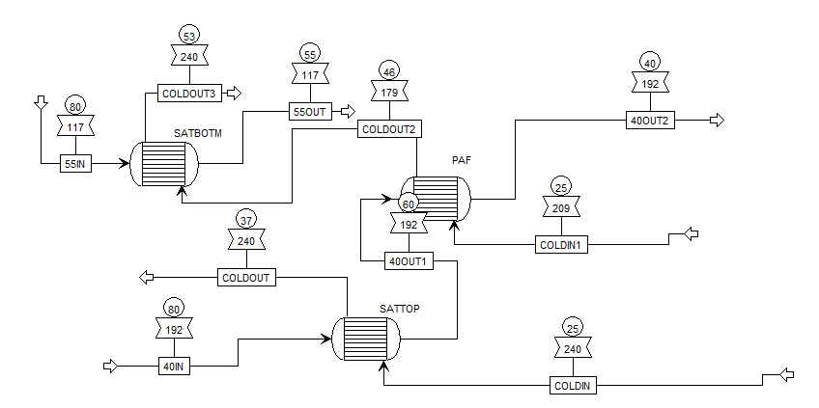

RUN 3:

-Black tube with hot water (80C) → top inlet on T-pipe on right side of apparatus→ bottom of T-pipe connects to far left pipe with automated valve → bottom of pipe connects tube inlet of the P&F exchanger (flow = 3.3 l/min and temperature = 65C) → outlet of P&F exchanger connects to inlet of bottom S&T exchanger → bottom of S&T exchanger attaches to open ended pipe (flow rate should be 3.3 l/min and temperature on outlet should be 40C)

- Black tube with hot water (80C) → top inlet on T-pipe on right side of apparatus → left outlet of T-pipe connects to second pipe with automated valve → bottom of pipe connects to tube inlet of top S&T exchanger → tube outlet of the bottom S&T exchanger connects to an open ended pipe → drain (flow rate should be 2 l/min and temperature on outlet should be 55C)

-Yellow tube #1 with cold water (25C) → connects to far left pipe with manual valve → bottom of pipe connects to inlet of the P&F (for counter current flow) → (flow rate at this point should be 3.5 l/min and temperature should be 44C) outlet of P&F exchanger connects to inlet of top S&T exchanger → outlet of S&T exchanger connects to open ended pipe → drain (flow rate should be at 2.5 l/min and temperature should be 64C)

-Yellow tube #2 with cold water (25C) → connects to far left pipe with manual valve → bottom of pipe connects to inlet of the bottom S&T exchanger → outlet of S&T exchanger connects to open ended pipe → drain (flow rate should be at 2.5 l/min and temperature at outlet should be 57C)

